ALGEBRA II Name: ________________________
Stats Percents

Directions: Show all equations and what you enter into your calculator.

- If 9 is x percent of 45, what is x percent of 50?
- If a > 0, and a percent of 10 is equal to 40% of b, what if the value of a/b?
- If 10 is 2% of z, what is 50% of z?
- 0.1 B. 5 C. 250 D. 500 E. 1000
- If 5% of x is y and 25% of y is z, the how many time larger than z is x?
- 4 B. 30 C. 80 D. 95 E. 125
- In an election with two parties, Party A won 54% of the votes. If Party B received 874 votes, how many votes were cast in total?
- In a college with 14,000 students, 490 are majoring in mathematics. What percentage of the student body does the number of math majors represent?
- If 95% of 3x is 39.9, what is the value of x?
- 10 B. 14 C. 38 D. 42 E. 58
- This week, the price of a plane ticket is $436. Over the next three weeks, suppose the price of the ticket rises 5% in the first week, falls 10% the next week, and then rises 20% in the third week. To the nearest cent, what is the cost of the plane ticket in 3 weeks?
- If $\frac{1}{2}\%$ of $\frac{x}{14}$ is $\frac{1}{4}$, then x =
A. 7 B. 70 C. 700 D. 70000 E. 70,000
- A student’s parking pass costs $45 per semester this year but last year cost only $38 per semester. To the nearest tenth of a percent, by what percentage has the price of a parking pass increased?
- In order for a school to allow a vending machine to be placed next to the cafeteria, 65% of the school’s population must ask for it. If 340 of the school’s 650 students have requested the vending machines, how many more are needed to get the vending machines?
- The percent increase from 8 to 14 is equal to the percent increase from 20 to what?
- 14 B. 26 C. 28 D. 32 E. 35
- The value of your investment increased from $1,500 to $1,800 over several years. What was the percentage increase of the investment?
- Of 2384 students of the school, 75% attempted the examination, of which 25 % failed. How many students passed the examination?
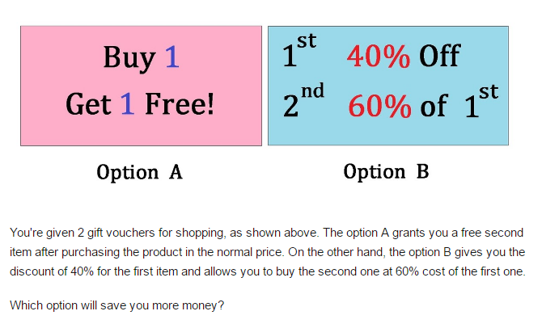

- Option A
- Option B
- Both offer the same price
- Not enough information

