Scatterplots / Correlation / Regression practice Name: _____________________________

DIRECTIONS: Enter your data on your calculator in List1 and List2. Use the Linear Regression (linreg) feature to calculator the line of best fit. Then answer the questions. Round all numbers to the hundredth place.

1) The following table contains the average tuition and room and board for full-time students at four-year colleges as published by the U.S. Department of Education, National Center for Education Statistics.

COLLEGE COSTS
ENDING YEAR | 2001 | 2003 | 2005 | 2007 | 2009 | 2011
Years Since 2001 | 0 | 2 | 4 | 6 | 8 | 10
Average Cost | 15,996 | 17,175 | 18,666 | 19,611 | 20,606 | 21,657
(Ending year means the year in which the school year ended, i.e. the 2008-2009 school year is represented by 2009.)

a. Linear Regression Equation. _____________________ Correlation Coefficient: ______________

b. According to the correlation value, is this model a good fit for the data? Why? __________________

c. What does the slope mean in the context of this data? _______________________________________

d. What does the $y$-intercept mean in the context of this data? ___________________________________

e. Use your linear regression equation to predict the college costs for school year, 2019-2020. __________

2) The following information was collected to see if there’s a correlation between the number of hours college students study per week and their grade point average.

Number of hours studying per week | Grade Point Average (out of 5.0)
5 | 2.0
10 | 3.22
10 | 2.82
14 | 3.91
18 | 3.48
25 | 3.79
32 | 4.81
42 | 4.98
a. Linear Regression Equation. _________________________

Correlation Coefficient: ____________

b. About how many hours would a student have to study per week to earn a 4.0 gpa? ____________________________

c. What does the slope mean in the context of this data? ____________________________________________

e. Use your linear regression equation to predict the gpa of a student who studies 12 hours a week. __________

3) The gas mileage for randomly selected cars based upon engine horsepower is given in the table.
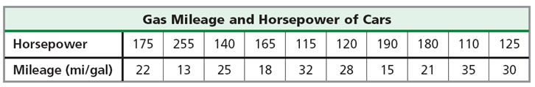

a. Linear Regression Equation. _____________________ Correlation Coefficient: ______________

b. What does the slope mean in the context of this data? _______________________________________

c. Use your linear regression equation to predict the gas mileage of a 210- horsepower engine? ________

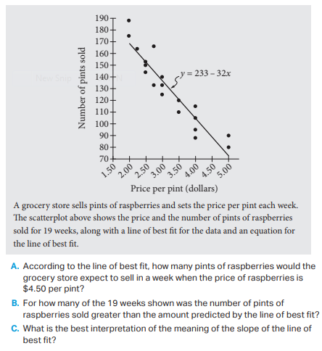
4) SAT/PSAT practice problem.
a. According to the line of best fit, how many pints of raspberries would the grocery store expect to sell in a week when the price of raspberries is $4.50 per pint? ____________

b. For how many of the 19 weeks shown was the number of pints of raspberries sold greater than the amount predicted by the line of best fit? _____________

c. What is the best interpretation of the meaning of the slope of the line of best fit? ___________________________________________

_________________________________________________

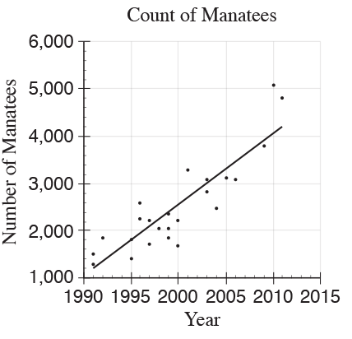

5) SAT/PSAT practice problem.

The scatterplot to the left shows counts of Florida manatees, a type of sea mammal, from 1991 to 2011. Based on the line of best fit to the data shown, which of the following values is closest to the average yearly increase in the number of manatees?

A. 0.75
B. 75
C. 150
D. 750

