Title of Quiz

__ 1.
a. |  | c.
b. |  | d.

___ 2.
a. | 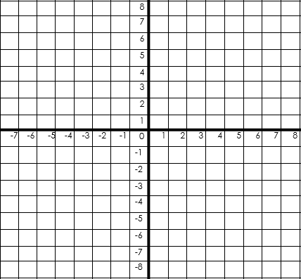 | c.
b. |  | d.

_ 3.
a. |  | c.
b. |  | d.

___ 4.
a. |  | c.
b. |  | d.

___ 5.

a. |  | c.
b. |  | d.

