 | Circle | Parabola | Ellipse | Hyperbola
Graph | 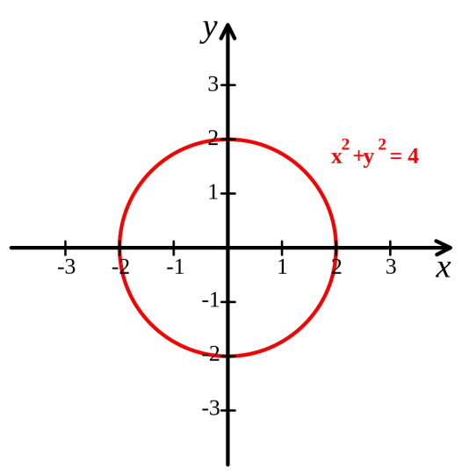 | 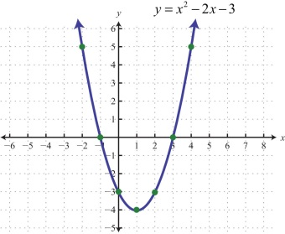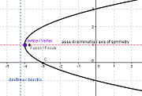 | 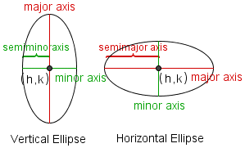 | Horizontal Vertical  Transverse axis determines orientation.  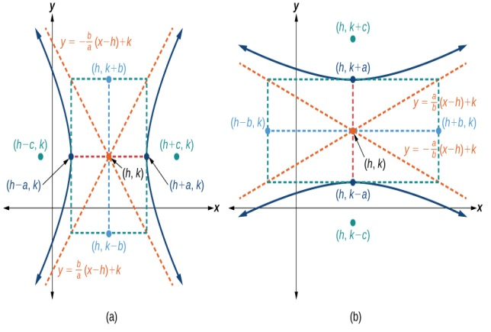
Equations | $$x^{2}+y^{2}=r^{2}$$  $${\left(x-h\right)}^{2}+{\left(y-k\right)}^{2}=r^{2}$$  2 squared terms,  same coefficients,  same signs | Vertical: $y=ax^{2}$  $y=a{\left(x-h\right)}^{2}+k$  Horizontal: $x=ay^{2}$  $x=a{\left(y-k\right)}^{2}+h$  1 squared term | Horizontal:  $$\frac{{(x-h)}^{2}}{a^{2}}+\frac{{(y-k)}^{2}}{b^{2}}=1$$  Vertical:  $$\frac{{(x-h)}^{2}}{b^{2}}+\frac{{(y-k)}^{2}}{a^{2}}=1$$  Two squared terms, different coefficients,  same signs. | Horizontal:  $$\frac{{(x-h)}^{2}}{a^{2}}-\frac{{(y-k)}^{2}}{b^{2}}=1$$  Asymptote: $(y-k)=±\frac{b}{a}(x-h)$  Vertical:  $$\frac{{(y-k)}^{2}}{a^{2}}-\frac{{(x-h)}^{2}}{b^{2}}=1$$  Asymptote: $(y-k)=±\frac{a}{b}(x-h)$  Two squared terms, any coefficient, different signs
Properties | Center (h,k)  Radius= r | Vertex (h,k)  $$p=\frac{1}{4a}$$  F: (h, k + $\frac{1}{4a}$), (h + $\frac{1}{4a}, k)$  D: y = k -$\frac{1}{4a}$ , x = h- $\frac{1}{4a}$  $FC:\left|\frac{1}{a}\right|$  Focus Vertex  P  Directrix Vertex | a$> b$ (Tells direction)  a = middle to vertex  2a = major axis  b = middle to co-vertex  2b = minor axis  c = middle to focus  a²- b²= c²  c < a | No restriction on a and b  a = middle to vertex on transverse axis  b = middle to other side of “box” on conjugate axis  c = middle to focus  a²+ b²= c²  a < c
Complete the square to put standard form into center/vertex form.

