Algebra 2
Absolute Value Graphs – Transformations
For #1 – 9 graph the given function using transformations of the parent function $y=|x|$
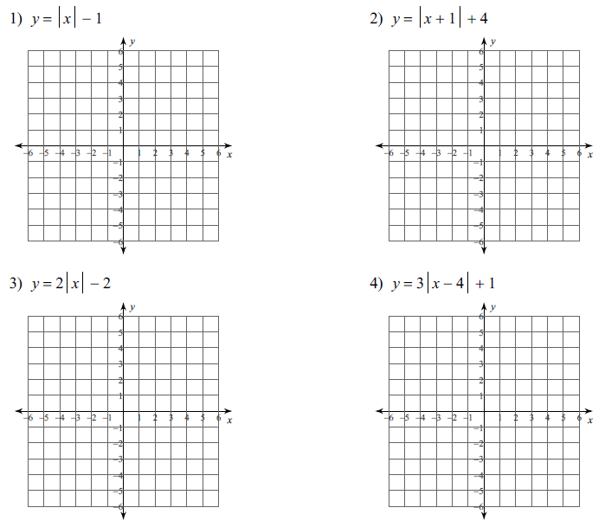

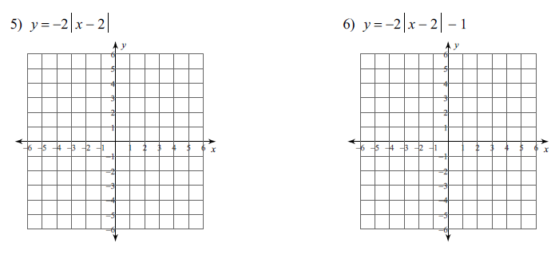

pg 1 of 2
7) $y=|2\left(x+5\right)|$ 8) $y=\left|\frac{1}{2}\left(x-1\right)\right|-3$
Algebra 2 Absolute Value Graphs – Transformations practice pg 2 of 2

9) $y=\left|\frac{2}{3}\left(x+3\right)\right|+2$
Describe the transformation:

10) $y=-\left|x-6\right|+2$

11) $y=\frac{1}{2} \left|x+2\right)-1$

12) $y=-4\left|x+7\right|+23$

Write an AbVal function to describe each transformation

13) vertex @ $\left(3, -5\right)$, opening down, stretched by a factor of 2

14) vertex moved left 9, up 4, compressed by a factor of $\frac{3}{5}$

15) vertex @ $(0, 3)$, opening up, stretched by a factor of 31

