ALGEBRA II Name _________________________ Date ______________

**REVIEW TRIG GRAPHING Sections 13.4-13.7**

**NO CALCULATOR**

**Find** **the** **amplitude** **and** **period** **of** **each** **sine** **curve.** **Then** **write** **an** **equation** **for** **each** **curve. How many cycles does the graph have over the interval 0 to 2π?**

**1.** 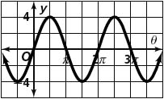  **2.** 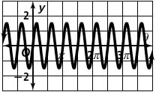  **3.** 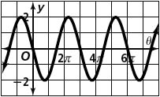

**4.** 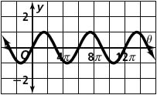  **5.** 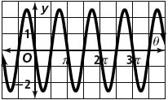  **6.** 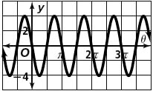

**Sketch** **one** **cycle** **of** **each** **sine** **curve.** **Assume** ***a*** **>** **0.** **Write** **an** **equation** **for** **each** **graph.**

**7.** amplitude = 2; period = *π* **8.** amplitude = 3; period = 2*π*

**9.** amplitude = 2; period =  **10.** amplitude = 2; period = 

**11.** amplitude = 1.5; period =  **12.** amplitude = 2.5; period = 2*π*

**Write** **an** **equation** **of** **a** **cosine** **function** **for** **each** **graph.**

**13. 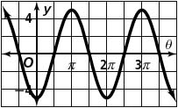 14. 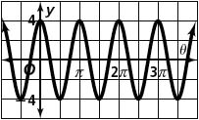 15.** 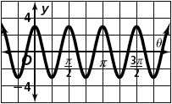

**Find** **the** **period** **and** **amplitude** **of** **each** **cosine** **function.**

**16. 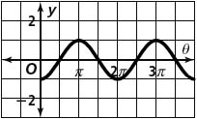 17. 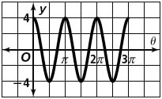 18.** 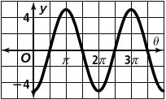

**Write** **a** **cosine** **function** **for** **each** **description.** **Assume** **that** ***a*** **>** **0.**

**19.** amplitude = 2, period = 1 **20.** amplitude = , period = *π*

**Write** **an** **equation** **for** **each** **translation.**

**21.** *y* = sin *x*, 2 units down **22.** *y* = cos *x*, *π* units left

**23.** *y* = cos *x*, units up **24.** *y* = sin *x*, 3.2 units to the right

**Graph** **each** **function** **in** **the** **interval** **from** **0** **to** **2*π*.**

**25.** *y* = −sin  **26.** *y* = cos $\left(\frac{1}{2}πx\right)+1$**27.** *y* = sin (2*x*) + 1

**28.** *y* = 3 cos (*x* − π/2) **29.** *y* = −2cos (*x*) + 3 **30.** *y* = sin ((*x* + *π*))

**31.** *y* =  cos (π*x*) + 3 **32.** *y* = −2 sin (π*x)* + 1 **33.** *y* =−cos $\left(2\right)$

**Find** **the** **amplitude** **and** **period** **of** **each** **function.** **Describe** **any** **phase** **shift** **and** **vertical** **shift** **in** **the** **graph.**

**34.** *y* = 3 cos (*x*) + 2 **35.** *y* = −2 sin  **36.** *y* = cos (2*x*) + 1

**37.** *y* = −sin  **38.** *y* =  cos (*x*) − 3 **39.** *y* = cos (*x*) – 2

**Find** **the exact** **trig ratio of each problem.**

**40.**  **41.**  **42.**   **43.** 

**44.**  **45.**  **46.**  **47.** 

**Given the trig ratio, find the angle,** , **in both degrees and radians.**

**48.**  **Degrees: ________, _________ Radians: ________, __________**

**49.**  **Degrees: ________, _________ Radians: ________, __________**

**50.**  **Degrees: ________, _________ Radians: ________, __________**