Graphing a Quadratic in Standard Form
Directions: Graph each quadratic by finding the axis of symmetry, vertex, and two other points. Show your work for each part.
- $y=2x^{2}+4x-5$  Axis of Symmetry:______________  (work)  Vertex: __________  (work)  y-intercept: ___________  (work)  Reflected Point: ___________ | 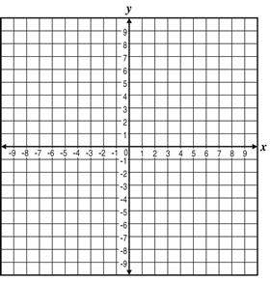
- $y=3x^{2}-9x+5$

Axis of Symmetry:______________
(work)

Vertex: __________
(work)

y-intercept: ___________
(work)

Reflected Point: ___________

- $f\left(x\right)={2x}^{2}-6x$

Axis of Symmetry:______________
(work)

Vertex: __________
(work)

y-intercept: ___________
(work)

Reflected Point: ___________

- $-4x^{2}-8x+3$

Axis of Symmetry:______________
(work)

Vertex: __________
(work)

y-intercept: ___________
(work)

Reflected Point: ___________

- $f\left(x\right)=\frac{1}{4}x^{2}+2x+1$

Axis of Symmetry:______________
(work)

Vertex: __________
(work)

y-intercept: ___________
(work)

Reflected Point: ___________

- $f\left(x\right)={-x}^{2}-4x-6$

Axis of Symmetry:______________
(work)

Vertex: __________
(work)

y-intercept: ___________
(work)

Reflected Point: ___________

