Graphing a Quadratic Inequality in Standard Form
Directions: Graph each quadratic by finding the axis of symmetry, vertex, two other points, and shading. Show your work for each part.
- $y>-x^{2}$  Axis of Symmetry:______________  (work)  Vertex: __________  (work)  y-intercept: ___________  (work)  Reflected Point: ___________  Shade: Above Below | 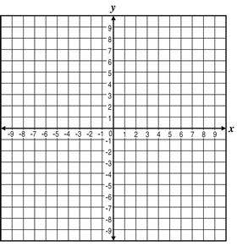
- $y≤3x^{2}+18x-8$

Axis of Symmetry:______________
(work)

Vertex: __________
(work)

y-intercept: ___________
(work)

Reflected Point: ___________
Shade: Above Below

- $f\left(x\right)≥x^{2}-6x$

Axis of Symmetry:______________
(work)

Vertex: __________
(work)

y-intercept: ___________
(work)

Reflected Point: ___________
Shade: Above Below

- $f\left(x\right)<-2x^{2}-8x-9$

Axis of Symmetry:______________
(work)

Vertex: __________
(work)

y-intercept: ___________
(work)

Reflected Point: ___________
Shade: Above Below

- A ball is thrown into the air with an initial upward velocity of 48ft/s. Its height h in feet after t seconds is given by the function$h=-16t^{2}+48t+4$.

- In how many seconds will the ball reach its maximum height?

- What is the balls maximum height?

- Suppose you have 80ft of fence to enclose a rectangular garden. The function $A=40x-x^{2}$ gives you the area of the garden in square feet where x is the width in feet.

- What width gives you the maximum gardening area?

- What is the maximum area?

- An athlete dives from the 3-meter springboard. Her height y, at horizontal distance x, can be approximated by the function $y=-1.2x^{2}+3.12x+3.$ Both the height and distance are in meters.

- How far has she traveled horizontally when she reaches her maximum height? Round to the nearest tenth of a meter.

- What is her maximum height? Round to the nearest tenth of a meter.

