To access the pictures for each section below, please go to:

[**Exploring Vertex Form of a Quadratic**](http://andrewbusch-bvsd.weebly.com/10i-snowboard-quadratic---alg1b.html)

**Section 1:**

1) Choose 2 of the pictures of skiers in Section 1.

2) Click on either the heading or the picture to go to the attached Desmos file.

3) Using the sliders, find 'a', 'h', and 'k' values to fit a quadratic equation onto the skier/snowboarder's path while they are in the air.

4) Describe how you got your function to match the path of the athlete.

5) What relationships can you find between the graph and your 'a', 'h', and 'k' values?

**Section 2:**

1) Choose 2 pictures of skiers/snowboarders from section 2.

2) Click on either the heading or the picture to go to the attached Desmos file.

3) Describe what happens to the graph as the a-value gets larger? What about when 'a' is negative?

4) How does the graph change when you change the h-value? Be specific.

5) How does the graph change when you change the k-value? Be specific.

6) Given a graph, how would you find the values for 'h' and 'k' without sliders?

**Section 3:**

1) Now, only choose 1 of pictures of snowboarders from section 3.

2) Click on either the heading or the picture to go to the attached Desmos file.

3) This time there will be one difference between these pictures and the previous section -- the vertex point plotted on the graph.

4) Revisit your explanation to #6 in section 2:

     "Given a graph, how would you find the values for 'h' and 'k' without sliders?"

     How would you change your explanation (if at all)?

5) After you find the 'h' and 'k' values for a graph, how can you find the 'a' value?

**Practice:**

Write the quadratic equation in vertex form for each graph. The parent function is the dashed line graph of y = x2. Hint: It helps to find where the five new points are on the transformed graph. The *a*-value is 1 for each graph below.

1) 2)

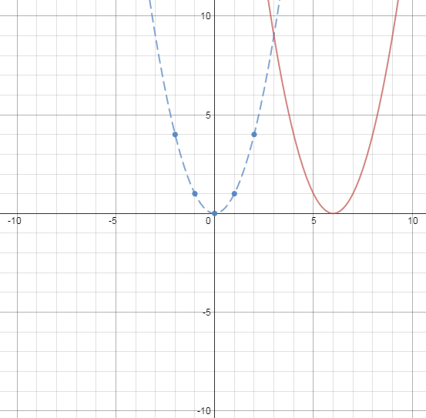 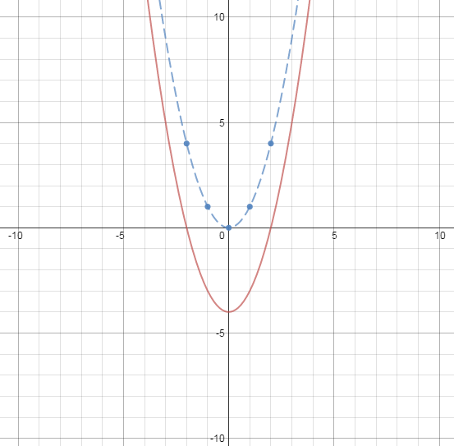

3) 4)

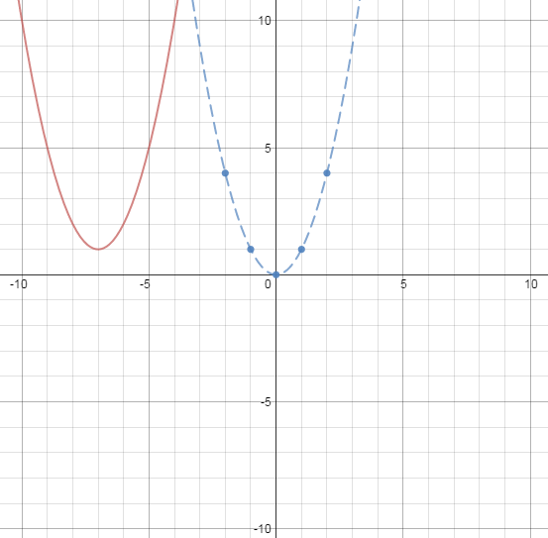 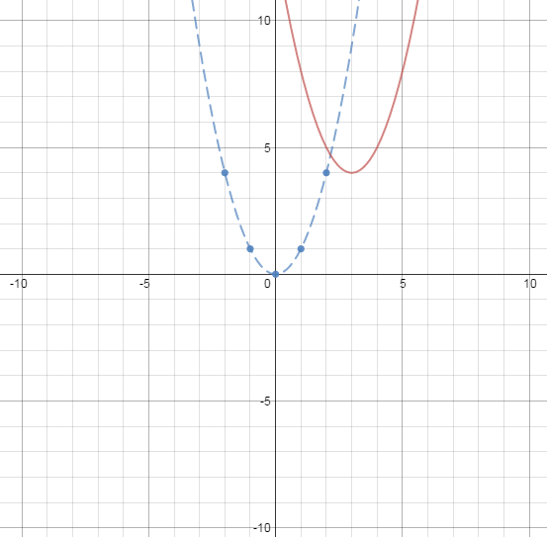

5) 6)

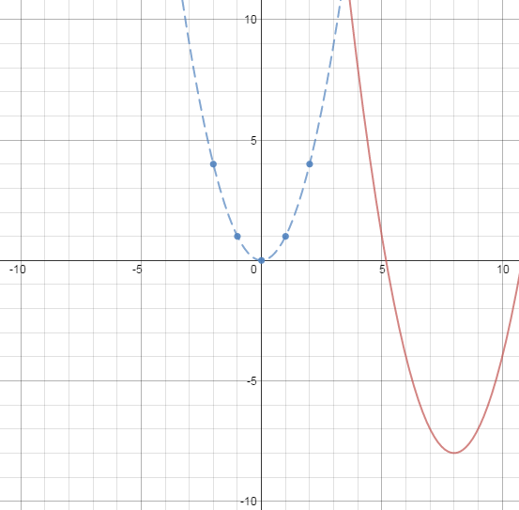 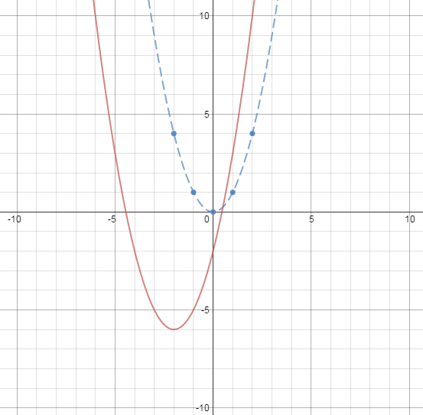

7) 8)

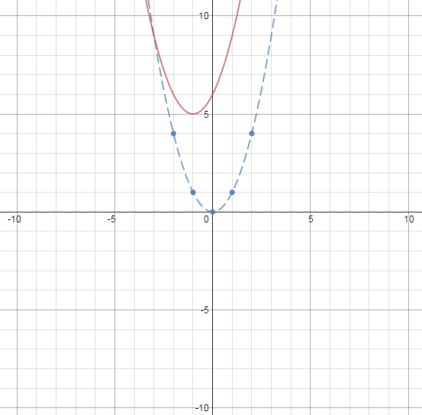 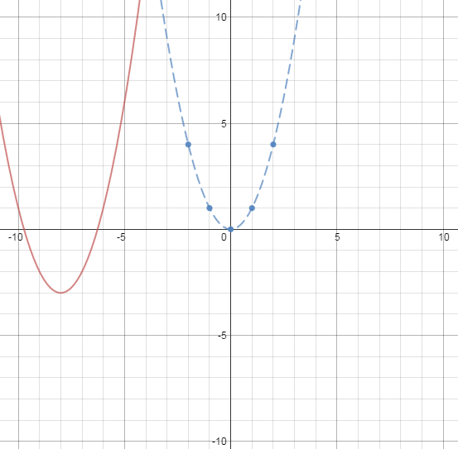

**For the following problems, graph the function by transforming each of the 5 points on the parent function. State the vertex and axis of symmetry for each.**

Example)  9) 

*Every point moves 3 to the right   
and 4 up.*

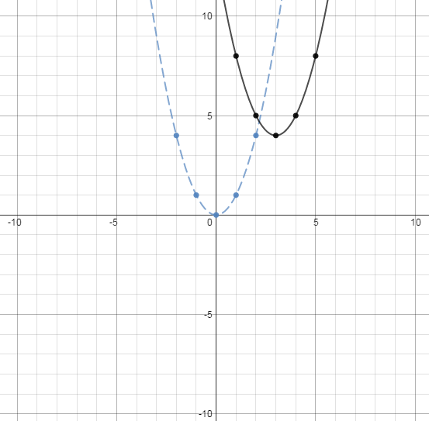 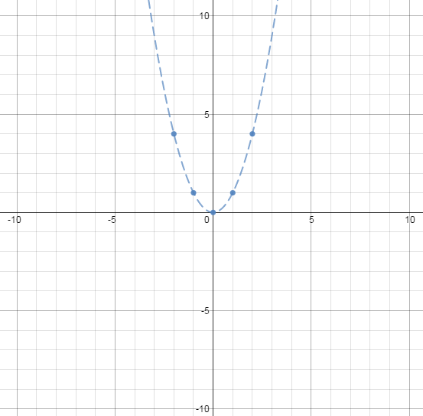

Vertex: (3, 4) Vertex: _______________________

Axis of Symmetry: x = 3 Axis of Symmetry:_______________

10)  11) 

 

Vertex: _______________________ Vertex: _______________________

Axis of Symmetry:_______________ Axis of Symmetry:_______________

12)  13) 

 

Vertex: _______________________ Vertex: _______________________

Axis of Symmetry:_______________ Axis of Symmetry:_______________

14)  15) 

 

Vertex: _______________________ Vertex: _______________________

Axis of Symmetry:_______________ Axis of Symmetry:_______________

Write each function in vertex form. When converting from standard form to vertex form, the *a*-values remain the same in each. Use a graphing utility to check your work.

16) 17) 18)

19) 20)